MAT 3749 2.3 Part III Handout
Maximum Value
A function has an (absolute) maximum at c if $f(c)≥f(x)$ for all x in D, where D is the domain of. The number is called the maximum value of on D.

Local Maximum
A function has a local maximum at c if $f(c)≥f(x)$ for all x in a neighborhood of c.

The Extreme Value Theorem
If is continuous on , then attains its maximum value and minimum value at some numbers and in .

Lemma (Homework)
(a) If $f^{'}(c)$ exists and is positive, then there is a neighborhood of on which
.
(b) If $f^{'}(c)$ exists and is negative, then there is a neighborhood of on which
.

Analysis

Fermat’s Theorem
If has a local maximum or minimum at , and if $f^{'}(c)$ exists, then$f^{'}(c)=0$.

Analysis

In light of the lemma, it makes sense to try using a contradiction.

Conceptual Diagrams

Case 1 | Then, by lemma, there is a neighborhood of such that  (1) in and  (2) in .
We want to show that does not have a local maximum at and does not have a local minimum at .
In order to show that does not have a local maximum at , what exactly do we need to demonstrate?

Which of the two conditions, (1) or (2), is relevant?

How does this condition implicate the statement above?

Proof

Suppose .

Case 1 .
Then, by lemma, there is a neighborhood of such that
(1) in and (2) in .

Let be any neighborhood of .
(1) in .
in such that
does not have a local maximum at .
(2) in .
in such that
does not have a local minimum at .

This is a contradiction to the fact that has a local maximum or minimum at .

Case 2 . (similar)

Thus, if has a local maximum or minimum at , and if $f^{'}(c)$ exists, then$f^{'}(c)=0$.

Rolle’s Theorem
Let be continuous on and differentiable on such that . Then such that .

Analysis

We have 3 conditions here. They may give us hints of how to approach this problem. On the other hand, we need to make sure we make use of all of them.

Conceptual Diagrams

After studying the conceptual diagrams, what do you think where we should choose ?

Based on the first condition, which previous result(s) is/are relevant?

Do we have enough to get exactly what we want to choose ? Why?

Not the end of the world…at least we get a good starting point.

Since f is continuous on , by EVT, attains its maximum value and minimum value at some .

If one of them is local, then we are done. If both are not local, we need to think about what to do.

If both are not local, where are and ?

What is the implication of these locations?

What does this tell you about the function ?

Where to choose ?

Good Job. We have resolve the case when has absolute maximum / minimum values at both endpoints.

Now, let us look carefully how to finish our proof when has local maximum / minimum values at either or .

In the actual proof, it is cleaner to use the cases and , rather than the equivalent statements above.

Suppose , how do we know one of and is not one of the end points?

We can conclude that at least one of are in . Let that point be .

Short stop for reality check

Which of the 3 conditions that we have not used?

Which previous result(s) is/are relevant?

Our gut feelings tell us that we need to use Fermat’s Theorem to show that .
We need to check the two hypotheses before we use it.

has a local maximum or minimum at . Why?

exists. Why?

We can now conclude that by Fermat’s Theorem, .

Proof
Since f is continuous on , by EVT, attains its maximum value and minimum value at some .

Case 1
is a constant function on . Thus, .
Choose any , we have .

Case 2
Since , are not both the endpoints.
Thus, at least one of are in . Let that point be .

So, attains its maximum or minimum value at .
That means has a local maximum or minimum at .
Since is differentiable on , exists. By Fermat’s Theorem, .

For all cases, we have proved that such that .

The Mean Value Theorem
Let be continuous on and differentiable on . Then such that
.

Analysis

What are the seminaries and differences between Rolle’s Theorem and the MVT? | Seminaries:  Differences:
Guess an approach to prove the MVT.

In order to use Rolle’s Theorem, we need a function such that
1. is continuous on
2. is differentiable on
3.

It looks like the most distinctive feature of is described by the last condition:

Refer to the diagram here, what geometric objects are there besides the curve of ?
Which of the two objects can be computed, given the hypothesis of the MVT?

Refer to the diagram again. Use geometric insights to create a function such that . | 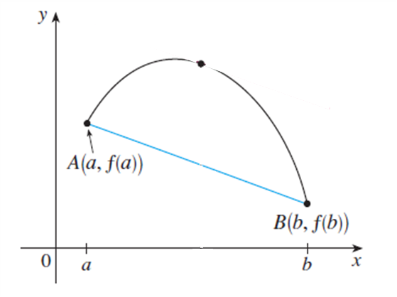

The equation of the secant line is
Let

It is routine to check the 3 conditions for Rolle’s Theorem.

What do we get from Rolle’s theorem?

Since is a straight line (linear polynomial), the slopes at all points are the same. Thus,
is the slope of the secant line connecting the two points.

Proof

Let and .
Since is a polynomial, it is continuous on and differentiable on .
So, is continuous on and differentiable on .
Also,
Now,
and

By Rolle’s Theorem, such that

Theorem If for all x in an interval , then is constant on .

Analysis

It is normal if you do not have a clue of how to proceed!

What does the title of this slide suggest?

Good observation!
Can we apply the MVT “directly”?

Ok, let us look at closely what we want. We want to show that  is constant on .  Can you describe a constant function on , verbally and mathematically? | Verbally:  Mathematically:
Follow this idea, let us choose two points on .
Let be any two numbers in . WLOG, let .

Draw a diagram to illustrate the positions of the 4 points .

Is differentiable on ? Why?
Is continuous on ? Why?
So, the hypothesis of the MVT is satisfied for on the interval between .

What conclusion we can get from the MVT?

What is the value of

What is the relationship between and ?

We have shown that . So is constant on .

Proof
Let be any two numbers in . WLOG, let .

is differentiable on is continuous on
Since , is continuous on .

is differentiable on .
Since , is differentiable on .

By the MVT, such that
Thus, is constant on .

Corollary If for all x in an interval , then on .

Proof | 